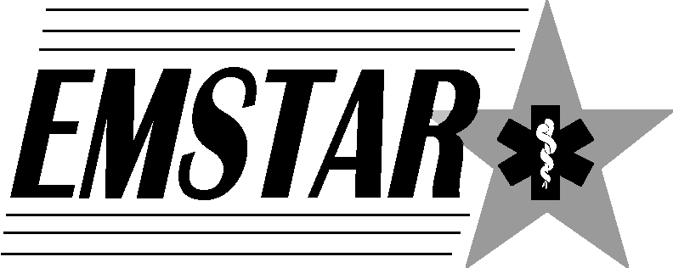
1058 West Church Street
Elmira, NY 14905
607-732-2354
emstar.org

Emergency
Medical
Services
Training
Administration &
Resources

Training attendance - BLOOD GLUCOMETRY
Course location: ____________________________________________________ Date: ____________________
Instructor: ___________________________________________ Start/End time: _________/___________
Brief training description: _________________________________________________________________________________________
______________________________________________________________________________________________________________
Name/Department | Full Home Address | Email & Phone

Name | Full Home Address | Email & Phone

